**Planning Meeting Minutes**

Date: October 30, 2023

Time: 7:00 PM - 9:00 PM

Location: Discord

**Attendees**

* 21127712 – Le Quang Truong Leader, Developer
* 21127443 – Tran Ngoc Truong Thinh Developer, Business Analyst
* 21127331– Nguyen Van Tuan Kiet Developer, Design
* 21127315 – Nguyen Gia Khanh Developer, Tester
* 21127606 – Bui Nguyen Hanh Developer, Tester

**Agenda**

* Project Status Update
* Discussion on planning for scrum meetings
* Action Items and Next Steps

**Discussion**

Project planning

* Trường hosted the meeting, created documents and summarized the team's ideas.
* Team members shared their progress and any potential roadblocks encountered.
* Kiệt, Khánh, Hanh discussed requirements for the project
* Thịnh, Trường decided tech stack for the project and suggested future plans

**Decisions**

1. The team agreed to proceed with the proposed campaign for the website
2. Tasks are assigned to each team member on Jira.

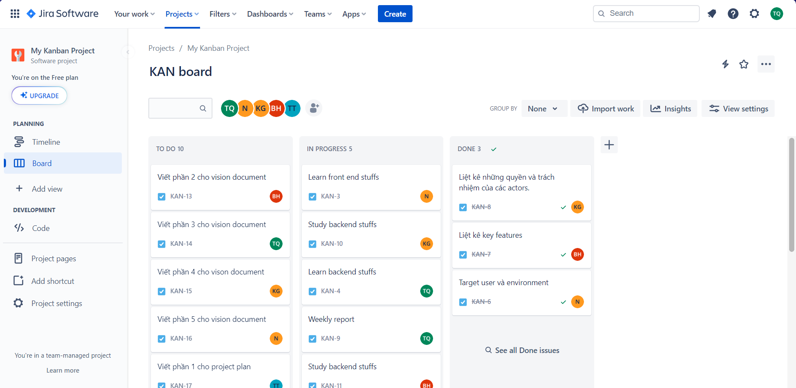

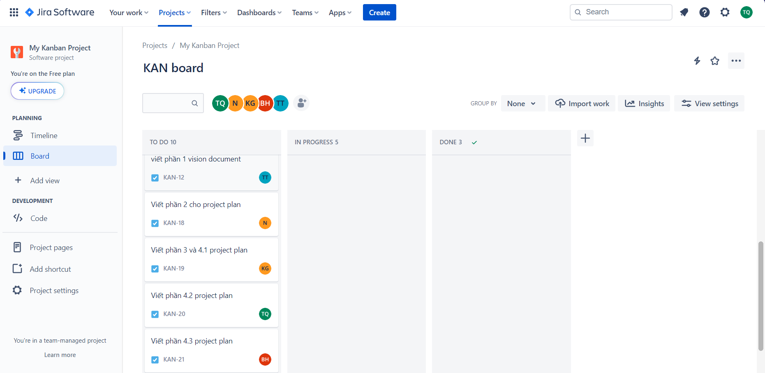

**Next Steps**

1. There will be 2 more meetings this week by Tuesday and Thursday.
2. Trường will announce the team when a change is needed.

**Adjournment**

The meeting concluded at 9:00 PM. The next meeting is scheduled for November 2, 2023, at 10:00 AM.

Prepared by:

Le Quang Truong(Team lead)